Ujian web
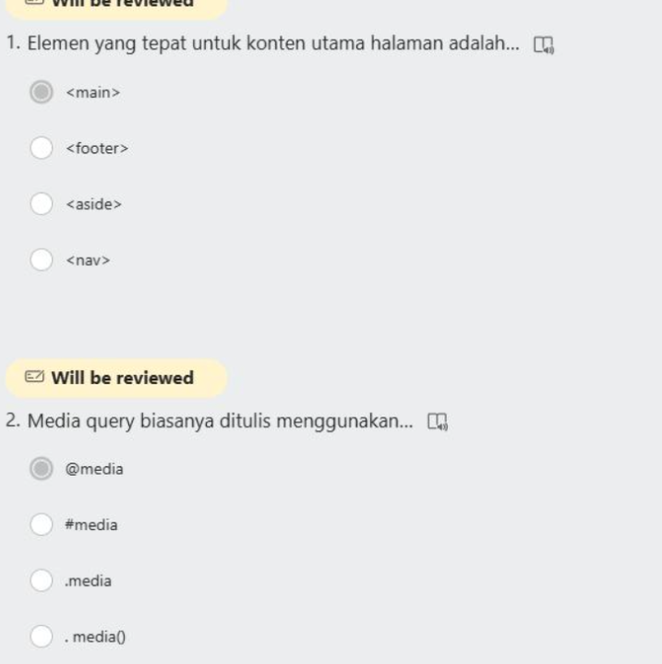

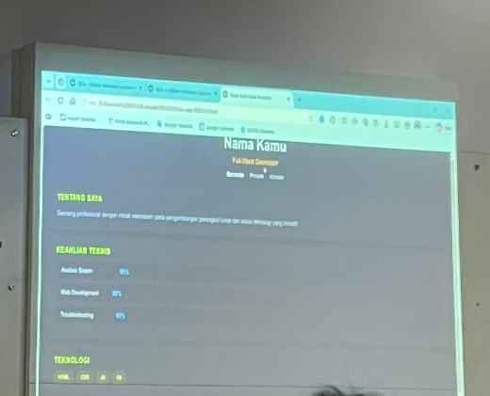
Jawaban :
Html:
<!DOCTYPE html>
<html lang="id">
<head>
<meta charset="UTF-8">
<meta name="viewport" content="width=device-width, initial-scale=1.0">
<title>Portofolio Saya</title>
<link rel="stylesheet" href="style.css">
</head>
<body>

<div class="container">
<!-- Header -->
<header>
<h1>Nama Kamu</h1>
<p class="role">Full Stack Developer</p>
<nav>
<a href="#">Beranda</a>
<a href="#">Proyek</a>
<a href="#">Kontak</a>
</nav>
</header>

<hr>

<!-- Tentang Saya -->
<section class="section">
<h2 class="title-section">TENTANG SAYA</h2>
<p>Seorang profesional dengan minat mendalam pada pengembangan perangkat lunak dan solusi teknologi yang kreatif.</p>
</section>
<!-- Keahlian Teknis -->
<section class="section">
<h2 class="title-section">KEAHLIAN TEKNIS</h2>
<div class="skill-item">
<span>Analisis Sistem</span>
<div class="progress-bar"><div class="progress" style="width: 90%;"></div></div>
<span class="percent">90%</span>
</div>

<div class="skill-item">
<span>Web Development</span>
<div class="progress-bar"><div class="progress" style="width: 85%;"></div></div>
<span class="percent">85%</span>
</div>

<div class="skill-item">
<span>Troubleshooting</span>
<div class="progress-bar"><div class="progress" style="width: 95%;"></div></div>
<span class="percent">95%</span>
</div>
</section>

<!-- Teknologi -->
<section class="section">
<h2 class="title-section">TEKNOLOGI</h2>
<div class="tech-stack">
<span class="badge">HTML</span>
<span class="badge">CSS</span>
<span class="badge">JS</span>
<span class="badge">PHP</span>
</div>
</section>
</div>

</body>
</html>
Css nya :
/* Reset Dasar */
* {
margin: 0;
padding: 0;
box-sizing: border-box;
font-family: 'Segoe UI', Tahoma, Geneva, Verdana, sans-serif;
}

body {
background-color: #2c2f33; /* Warna background gelap */
color: #ffffff;
display: flex;
justify-content: center;
padding: 50px 20px;
}

.container {
background-color: #3e4146; /* Warna card utama */
width: 100%;
max-width: 800px;
padding: 40px;
border-radius: 8px;
box-shadow: 0 10px 30px rgba(0,0,0,0.5);
}

/* Header */
header {
text-align: center;
margin-bottom: 20px;
}

header h1 {
font-size: 2rem;
margin-bottom: 5px;
}

.role {
color: #e67e22; /* Warna orange untuk role */
font-weight: bold;
margin-bottom: 15px;
}

nav a {
color: #ffffff;
text-decoration: none;
margin: 0 10px;
font-size: 0.9rem;
}

hr {
border: 0;
border-top: 1px solid #555;
margin: 20px 0;
}

/* Section */
.section {
margin-bottom: 30px;
}

.title-section {
color: #ccff00; /* Warna hijau neon sesuai foto */
font-size: 1.1rem;
margin-bottom: 15px;
}

p {
font-size: 0.95rem;
line-height: 1.6;
color: #ccc;
}

/* Progress Bar Keahlian */
.skill-item {
display: flex;
align-items: center;
margin-bottom: 15px;
}

.skill-item span {
width: 150px;
font-size: 0.9rem;
}

.progress-bar {
flex-grow: 1;
background-color: #555;
height: 12px;
border-radius: 6px;
margin: 0 15px;
overflow: hidden;
}

.progress {
background-color: #3498db; /* Warna biru progress bar */
height: 100%;
}

.percent {
width: 40px !important;
text-align: right;
color: #3498db;
}

/* Teknologi Badges */
.tech-stack {
display: flex;
gap: 10px;
}

.badge {
background-color: #f1c40f;
color: #000;
padding: 5px 12px;
border-radius: 4px;
font-weight: bold;
font-size: 0.8rem;
}

Jawaban kuis kls sblh:
Html nya
<!DOCTYPE html>
<html lang="id">
<head>
<meta charset="UTF-8">
<meta name="viewport" content="width=device-width, initial-scale=1.0">
<title>Portofolio Saya - John Doe</title>
<link rel="stylesheet" href="style.css">
<!-- Menggunakan Font Awesome untuk icon (opsional, sesuai gambar) -->
<link rel="stylesheet" href="https://cdnjs.cloudflare.com/ajax/libs/font-awesome/6.0.0/css/all.min.css">
</head>
<body>

<!-- Header & Navbar (Flexbox 1) -->
<header>
<div class="container navbar">
<h1 id="logo">Portofolio Saya</h1>
<nav>
<ul class="nav-links">
<li><a href="#profil" class="active">Profil</a></li>
<li><a href="#project">Project</a></li>
<li><a href="#kontak">Kontak</a></li>
</ul>
</nav>
</div>
</header>

<!-- Section Profil -->
<section id="profil" class="section-padding">
<div class="container profil-grid">
<img src="https://via.placeholder.com/150" alt="Foto Profil John Doe" class="profile-img">
<div class="profil-text">
<h2>John Doe</h2>
<p>Saya seorang web enthusiast yang suka belajar teknologi baru. Saya juga tertarik dalam pengembangan backend dan frontend. Selalu berusaha membuat sesuatu yang bermanfaat dan kreatif.</p>
</div>
</div>
</section>

<!-- Section Project (Flexbox 2) -->
<section id="project" class="section-padding bg-light">
<div class="container text-center">
<h3 class="section-title">Project Saya</h3>
<div class="project-list">
<!-- Project 1 -->
<div class="card">
<div class="icon-circle bg-green"><i class="fas fa-shopping-cart"></i></div>
<h4>Website Toko Online</h4>
<p>Aplikasi e-commerce sederhana menggunakan HTML & CSS.</p>
</div>
<!-- Project 2 -->
<div class="card">
<div class="icon-circle bg-blue"><i class="fas fa-list-ul"></i></div>
<h4>Aplikasi Todo List</h4>
<p>Aplikasi untuk mengelola tugas harian dengan tampilan sederhana.</p>
</div>
<!-- Project 3 -->
<div class="card">
<div class="icon-circle bg-purple"><i class="fas fa-desktop"></i></div>
<h4>Landing Page</h4>
<p>Halaman promosi produk dengan desain modern dan responsif.</p>
</div>
</div>
</div>
</section>

<!-- Section Kontak -->
<section id="kontak" class="section-padding">
<div class="container text-center">
<h3 class="section-title">Kontak</h3>
<p>Hubungi saya di:</p>
<div class="social-links">
<a href="mailto:email@example.com" class="link-item"><i class="far fa-envelope"></i> Email Saya</a>
<a href="#" class="link-item"><i class="fab fa-instagram"></i> Instagram</a>
<a href="#" class="link-item"><i class="fab fa-linkedin"></i> LinkedIn</a>
</div>
</div>
</section>

<!-- Footer -->
<footer>
<p>&copy; 2026 John Doe</p>
</footer>

</body>
</html>

Css:
/* Reset Dasar */
* {
margin: 0;
padding: 0;
box-sizing: border-box;
font-family: 'Segoe UI', Tahoma, Geneva, Verdana, sans-serif;
}

body {
line-height: 1.6;
color: #2c3e50; /* Warna Utama 1 */
background-color: #ffffff;
}

.container {
max-width: 1000px;
margin: 0 auto;
padding: 0 20px;
}

.section-padding {
padding: 60px 0;
}

.text-center {
text-align: center;
}

.bg-light {
background-color: #f4f6f8;
}

/* Header & Navbar (Ketentuan Flexbox 1) */
header {
background-color: #1a252f; /* Background berbeda */
color: #ffffff;
padding: 20px 0;
}

.navbar {
display: flex;
justify-content: space-between;
align-items: center;
}

.nav-links {
display: flex;
list-style: none;
}

.nav-links li {
margin-left: 30px;
}

.nav-links a {
color: #ffffff;
text-decoration: none;
font-weight: 500;
transition: 0.3s;
}

/* Hover Menu & Active State */
.nav-links a:hover, .active {
color: #1abc9c; /* Warna Utama 2 */
}

.active {
border-bottom: 2px solid #1abc9c;
}

/* Section Profil */
.profil-grid {
display: flex;
align-items: center;
gap: 40px;
}

.profile-img {
width: 180px; /* Ukuran maksimal */
height: 180px;
border-radius: 50%; /* Rounded */
object-fit: cover;
}

/* Section Project (Ketentuan Flexbox 2 & Card) */
.section-title {
margin-bottom: 40px;
font-size: 24px;
}

.project-list {
display: flex;
gap: 20px;
justify-content: space-between;
}

.card {
background: #ffffff;
padding: 30px 20px;
border-radius: 10px; /* Border radius */
box-shadow: 0 4px 15px rgba(0,0,0,0.1); /* Box shadow */
flex: 1;
transition: transform 0.3s ease, box-shadow 0.3s ease; /* Interaksi transition */
}

/* Hover Card */
.card:hover {
transform: translateY(-10px); /* Efek naik */
box-shadow: 0 10px 25px rgba(0,0,0,0.15);
}

.icon-circle {
width: 60px;
height: 60px;
border-radius: 50%;
display: flex;
align-items: center;
justify-content: center;
margin: 0 auto 20px;
font-size: 24px;
color: white;
}

.bg-green { background-color: #1abc9c; }
.bg-blue { background-color: #3498db; }
.bg-purple { background-color: #9b59b6; }

/* Section Kontak & Link */
.social-links {
display: flex;
justify-content: center;
gap: 30px;
margin-top: 20px;
}

.link-item {
text-decoration: none;
color: #2c3e50;
font-weight: bold;
transition: color 0.3s;
}

/* Hover Link */
.link-item:hover {
color: #3498db;
}

/* Footer */
footer {
background-color: #1a252f;
color: #ffffff;
text-align: center;
padding: 20px 0;
}

/* Responsive sederhana */
@media (max-width: 768px) {
.navbar, .profil-grid, .project-list, .social-links {
flex-direction: column;
text-align: center;
}
}

